HOMEWORK

NAME: Arrieta Almeida Evelyn Gabriela

COURSE: 3 Accounting “C”

MUSTN’T

You mustn't go into a house that it's not yours

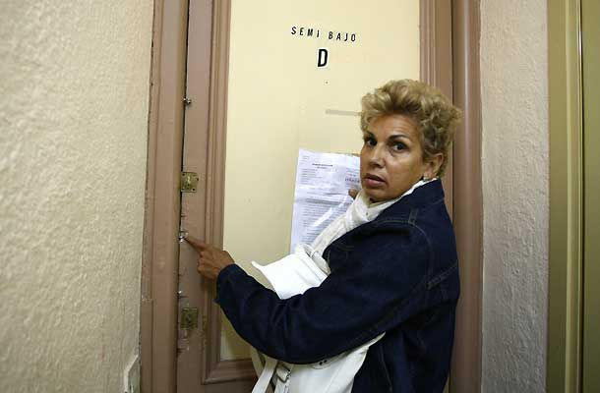

You mustn't steal money from a bank



You mustn't lie to your parents



MUST

I must do my homework



You must jump there



You must brush your teeth



SHOULD  
You should drink a glass of water



You should see a dentist



I should study this chapter for the exam



**SHOULDN’T**

We shouldn't arrive late

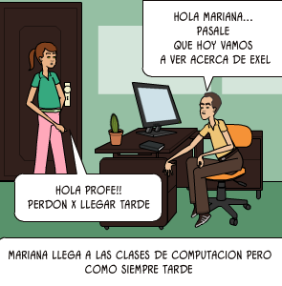

I think you shouldn't work harder

